**T. Y. B. Tech (Electrical and Computer Engineering)**

**Trimester: V Subject: Microcontroller and Applications**

**Name: Shreerang Mhatre Class: TY**

**Roll No: 52 Batch: A3**

**Experiment No: 09**

**Name of the Experiment:** Interfacing of Stepper motor with C8051F340.

**Marks**

**Teacher’s Signature with date**

**Performed on: 31/10/2023**

**Submitted on: 07/11/2023**



**Aim:** Write C program for interfacing of Stepper motor with C8051F340 to rotate in clockwise and anticlockwise direction.

**Apparatus:** EPBF340 board, Stepper motor Board

**Theory:**

A stepper motor is known by its important property to convert a train of pulses into a precisely defined increment in the shaft position. A stepper motor is a widely used a device that translates electrical pulses into mechanical movement. In applications such as disk drivers, dot matrix printers, and robotics, the stepper motor is used for position control. Every stepper motor has a permanent magnet rotor ( also called as shaft ) surrounded by a stator the most common stator motors have four stator windings that are paired with a centre-tapped common as shown in the figure. This type of stator motor is commonly referred to as four phase stepper motor. The centre tap allows a change of current direction in each of two coils, when a winding is grounded, thereby resulting in polarity change of the stator. Notice that while a conventional motor shaft runs freely, the stepper motor shaft moves in a fixed repeatable increment which allows one to move it to a precise position.

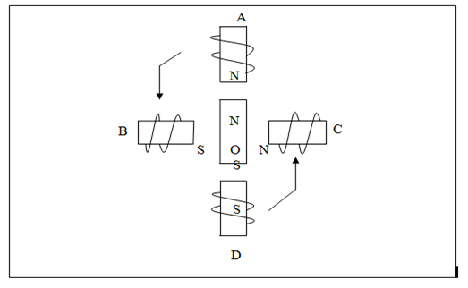

*Figure 8.1 Stepper motor windings*

This repeatable fixed movement is possible as a result of basic magnetic theory where poles of same polarity repel and opposite attract. The direction of rotation is indicated by the stator poles. The stator poles are determined by the current sent through the wire coils A, B,C and D as shown in Figure 8.1. As the direction of current is changed, the polarity is also changed causing the reverse motion of the rotor. The stepper motor discussed here has a total of six leads: four leads representing the four stator windings and two commons for the centre tapped leads. As the sequence of power is applied to each stator winding, the rotor will rotate. There are several widely used sequences where each has a different degree of precision. The stepping sequence of excitations is as shown in Table 8.1.

Table 8.1 The stepping sequence

|  |  |  |  |  |  |  |  |  |
| --- | --- | --- | --- | --- | --- | --- | --- | --- |
| **Windings** | **D** |  | **C** |  | **B** |  | **A** |  |
| **Sequence in hex on Port 4** | **P4.7** | **P4.6** | **P4.5** | **P4.4** | **P4.3** | **P4.2** | **P4.1** | **P4.0** |
| 0A | 0 | 0 | 0 | 0 | 1 | 0 | 1 | 0 |
| 88 | 1 | 0 | 0 | 0 | 1 | 0 | 0 | 0 |
| A0 | 1 | 0 | 1 | 0 | 0 | 0 | 0 | 0 |
| 22 | 0 | 0 | 1 | 0 | 0 | 0 | 1 | 0 |

**Types of Stepper Motor:**

There are three main types of stepper motors, they are:

1. Permanent magnet stepper
2. Hybrid synchronous stepper
3. Variable reluctance stepper

**Permanent Magnet Stepper Motor:** Permanent magnet motors use a permanent magnet (PM) in the rotor and operate on the attraction or repulsion between the rotor PM and the stator electromagnets.

**Variable Reluctance Stepper Motor:** Variable reluctance (VR) motors have a plain iron rotor and operate based on the principle that minimum reluctance occurs with minimum gap, hence the rotor points are attracted toward the stator magnet poles.

**Hybrid Synchronous Stepper Motor:** Hybrid stepper motors are named because they use a combination of permanent magnet (PM) and variable reluctance (VR) techniques to achieve maximum power in a small package size.

**Advantages of Stepper Motor:**

1. The rotation angle of the motor is proportional to the input pulse.
2. The motor has full torque at standstill.
3. Precise positioning and repeatability of movement since good stepper motors have an accuracy of 3 – 5% of a step and this error is non-cumulative from one step to the next.
4. Excellent response to starting, stopping and reversing.
5. Very reliable since there are no contact brushes in the motor. Therefore the life of the motor is simply dependant on the life of the bearing.
6. The motors response to digital input pulses provides open-loop control, making the motor simpler and less costly to control.
7. It is possible to achieve very low speed synchronous rotation with a load that is directly coupled to the shaft.
8. A wide range of rotational speeds can be realized as the speed is proportional to the frequency of the input pulses.

**Applications:**

1. **Industrial Machines** – Stepper motors are used in automotive gauges and machine tooling automated production equipment.
2. **Security** – new surveillance products for the security industry.
3. **Medical** – Stepper motors are used inside medical scanners, samplers, and also found inside digital dental photography, fluid pumps, respirators and blood analysis machinery.
4. **Consumer Electronics** – Stepper motors in cameras for automatic digital camera focus and zoom functions.

**Interfacing Diagram:**

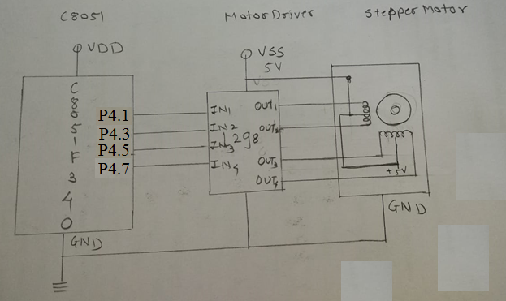

*Figure 8.2 Interfacing Diagram of stepper motor with C8051F340*

**Hardware Connections:**

Connect flat cable between PL3 connector of ASK25 and PL6 connector of EPBF340 board. Connect stepper motor at PL4 connector of ASK25. Connect 9V power supply at PL9 connector of ASK25 before connecting the stepper motor. Press DIP switch SW9 on ASK25 to run the motor.

|  |  |  |
| --- | --- | --- |
| Pin Connection | PL3 Connector of ASK25 | PL6 Connector of EPBF340 |
| 11 | Input 1 (A) | P4.1 |
| 13 | Input 2 (B) | P4.3 |
| 15 | Input 3 (C) | P4.5 |
| 17 | Input 4 (D) | P4.7 |
| 19 | 5V | 5.0 V |
| 20 | GROUND | GND |

**Program:** Attach printout of the tested code.

**Expected Result:**

Stepper Motor will rotate in the clockwise and anticlockwise direction

**Conclusion:**

**---------------------------------------------------------------------------------------------------------------------------------------------------------------------------------------------------------------------------------------------------------------------------------------------------------------------------------------------------------------**

**Study Questions:**

1. Explain different types of stepper motors and its applications.
2. Explain full stepping & half stepping concept of stepper motor.
3. List specifications of stepper motor and explain need of diver.

**Additional Links:**

*https://nptel.ac.in/courses/112103174/16*

**Interfacing of Stepper motor with C8051F340.**

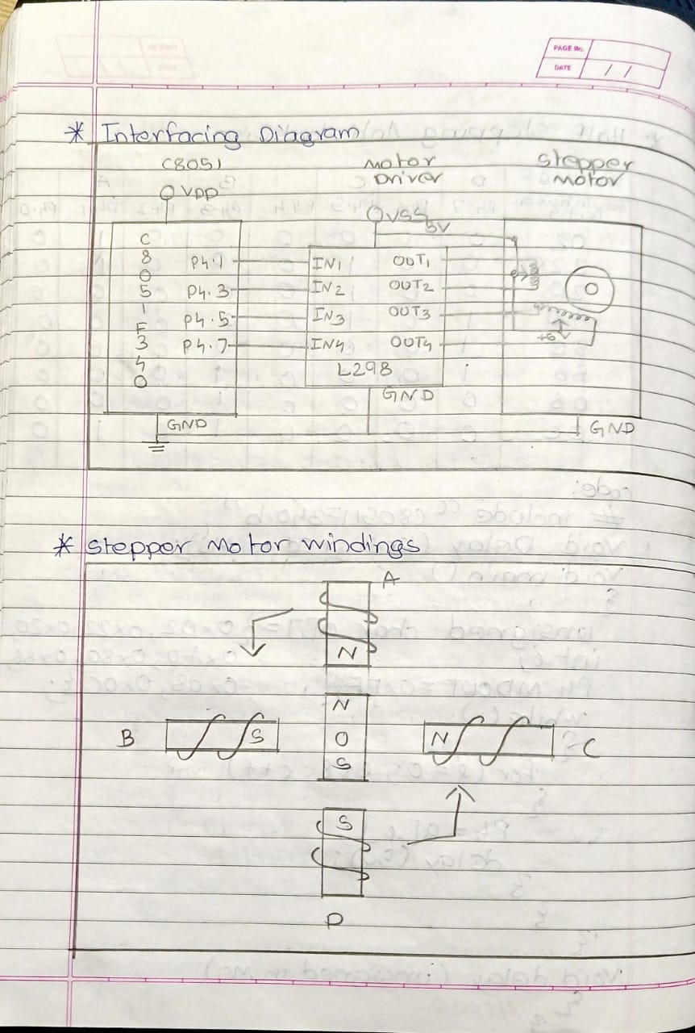

**Code for Full Stepping in Clockwise Direction:**

// Exp 9 Interfacing of Stepper motor with C8051F340

// Full Stepping in Clockwise Direction

/*

Name: Shreerang Mhatre

Rollno: 52

Batch: A3

Class: TY

*/

#include "C8051F340.h"

void delay(unsigned int Ms);

void main()

{

    char a[4]={0x02, 0x20, 0x80, 0x08};

    int i;

    P4MDOUT=0xFF;

    while(1)

    {

        for(i=0; i<4;i++)

        {

            P4=a[i];

            delay(60);

        }

    }

}

void delay(unsigned int Ms)

{

    unsigned int n;

    unsigned int j;

    for(n=0;n<Ms;n++)

    {

        for(j=0;j<65;j++);

    }

}

**Code for Full Stepping in AntiClockwise Direction:**

// Exp 9 Interfacing of Stepper motor with C8051F340

// Full Stepping in AntiClockwise Direction

/*

Name: Shreerang Mhatre

Rollno: 52

Batch: A3

Class: TY

*/

#include "C8051F340.h"

void delay(unsigned int Ms);

void main()

{

    char a[4]={0x02,0x08, 0x80, 0x20};

    int i;

    P4MDOUT=0xFF;

    while(1)

    {

        for(i=0; i<4;i++)

        {

            P4=a[i];

            delay(60);

        }

    }

}

void delay(unsigned int Ms)

{

    unsigned int n;

    unsigned int j;

    for(n=0;n<Ms;n++)

    {

        for(j=0;j<65;j++);

    }

}

**Code for Half Stepping in Clockwise Direction:**

// Exp 9 Interfacing of Stepper motor with C8051F340

// Half Stepping in Clockwise Direction

/*

Name: Shreerang Mhatre

Rollno: 52

Batch: A3

Class: TY

*/

#include "c8051F340.h"

void delay(unsigned int Ms);

void main()

{

    char a[]={0x02, 0x22, 0x20, 0xA0,0x80,0x80,0x88,0x0C};

    int i;

    P4MDOUT=0xFF;

    while(1)

    {

        for(i=0; i<8;i++)

        {

            P4=a[i];

            delay(60);

        }

    }

}

void delay(unsigned int Ms)

{

    unsigned int n;

    unsigned int j;

    for(n=0;n<Ms;n++)

    {

        for(j=0;j<65;j++);

    }

}

**Code for Half Stepping in AntiClockwise Direction:**

// Exp 9 Interfacing of Stepper motor with C8051F340

// Half Stepping in AntiClockwise Direction

/*

Name: Shreerang Mhatre

Rollno: 52

Batch: A3

Class: TY

*/

#include "c8051F340.h"

void delay(unsigned int Ms);

void main()

{

    char a[]={0x02, 0x0A, 0x08, 0x88,0x80,0xA0,0x20,0x22};

    int i;

    P4MDOUT=0xFF;

    while(1)

    {

        for(i=0; i<8;i++)

        {

            P4=a[i];

            delay(60);

        }

    }

}

void delay(unsigned int Ms)

{

    unsigned int n;

    unsigned int j;

    for(n=0;n<Ms;n++)

    {

        for(j=0;j<65;j++);

    }

}

**Demonstration of Full Stepping and Half Stepping in Clockwise Direction**

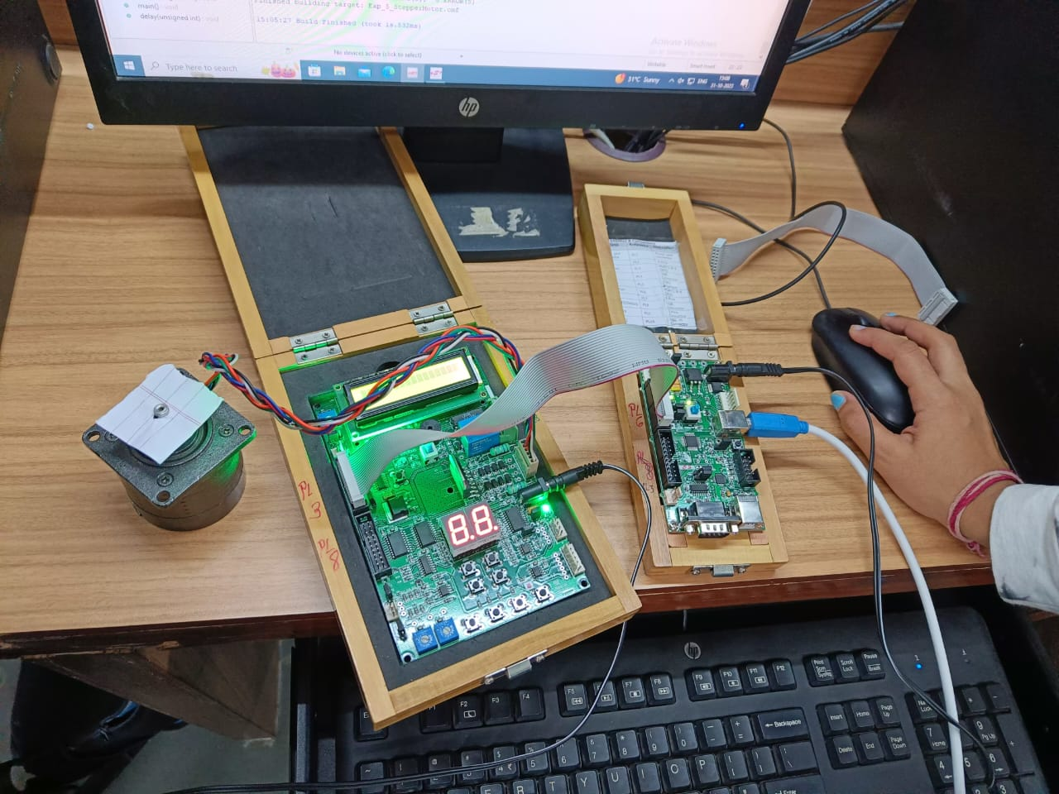

**Demonstration of Full Stepping and Half Stepping in AntiClockwise Direction**

